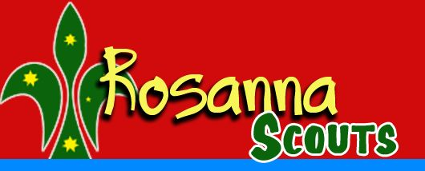66th Melbourne Gang Show,
Family BBQ & Cub Sleepover!
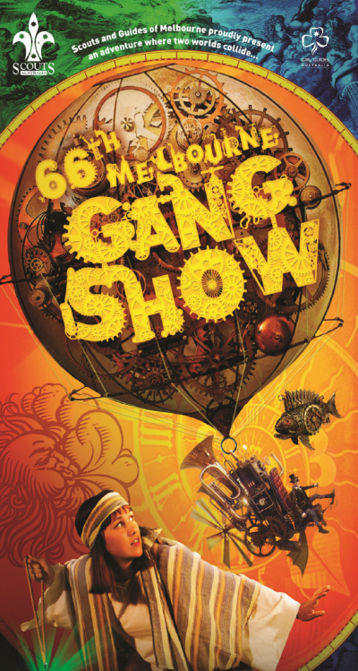The Scouts and Guides of Victoria present the 66th Melbourne Gang Show, at the Besen Centre, Burwood.

See also: http://www.gangshow.org

Rosanna Cubs, Scouts, Venturers & Rovers (AND parents, siblings etc., welcome too!) will attend the 2pm performance on Saturday, 23rd of June.

Following the performance, we’ll be coming back to the Hall for a family BBQ, and then the Scouts/Venturers/Rovers, parents and siblings will leave and the Cubs will have a sleepover.

This Year we’ll again be inviting 1st Bendigo Cubs, to come along to our BBQ and Sleepover after Gang Show!

Costs for the performance (bulk discount) and afterwards are:
- Adults/Children: $18
- Family BBQ: $5 per person
- Cub Sleepover: $5 per Cub

We need to get our bookings in for the show as soon as possible, to enable us to get the best possible seats at the performance. Once we’ve put the booking in, you may still be able to buy tickets for the performance, but you’ll be seated elsewhere in the theatre and the ticket prices will be higher, due to missing the bulk discount.

Please return the tear off form – RETURN IT with money by Tue 1st May (Cubs), Wed 2nd May (Scouts/ Venturers/ Rovers), BUT please email me now at akela@rosannacubs.org ! We’ll then get tickets organised.
Come along and have a ball!

66th Melbourne Gang Show, 2018
We’re coming along….
(1) Family Name:______________________ Youth Member(s):____________________

(2) TOTAL tickets required (Youth members & Family): _____________ x $18 = $____

(3) Attending the BBQ? Adults: _________ + Children: _________ = Tot:_________ x $5 = $____

(4) Cub(s) staying for sleepover – Name(s): _____________________________ x $5 each = $____

Money required for Cubs – 1/5, Scouts/Venturers/Rovers – 2/5, so we can get tickets. Total: = $_____
Please no Cheques or Transfers… CASH ONLY!

Please email NOW re Gang Show numbers, to akela@rosannacubs.org If unable to attend, please email to let us know.

